Assignment 1: Be careful with ‘==’

- Check the result of this program. Comment why this happened.
We ran the following code in R.
x1<-1/3;
x2<-1/4;
if (x1-x2==1/12){
print("Teacher said true")
} else{
print("Teacher lied")}
We get the following results.
[1] "Teacher lied"
As 1/3 is a repeating decimal number it cannot be represented perfectly by a computer (as it has infinite digits). Hence in R 1/3 is stored as an approximation (because of space constraints in mantissa). Hence when we compare 1/3 -1/4 to 1/12, we compare two approximate numbers. As R doesn’t know the two numbers with exact precision, it cannot determine if the two numbers are equal or not. Hence R always return false for the equality (as it is not sure). Well, not exactly true. Try to run 1/3 -1/4-1/12 and you will understand.
- Specify how the program can be modified to give a correct result

In order to rectify the problem we first calculate the value of machine epsilon (upper bound on the rounding off error). This number is the smallest number (for a specific floating point format) that can be represented by mantissa part of floating point representation. If the difference between our numbers is less than this smallest number then they can be assumed to be almost equal (up to the precision that we have).
#Computes machine epsilon. If you try to find macheps by successively
# dividing by 2 and comparing to zero, the algorithm simply returns zero
macheps=function(){
me=1.0
while(1+me>1){
me=me/2.0
}
me
}
We create a function for equality named ‘approxequal’ that correctly equates two variables.

approxequal=function(num1, num2)
{
res=FALSE;
e = macheps();
if ( abs(num1-num2) < e )
{
res = TRUE;
}
else
{
res = FALSE;
}
res
}
It compares the two numbers correctly as shown by the output from R below.

IDEA is correct but the way you compute machine epsilon does not give you real machine eps.
> approxequal(1/3-1/4, 1/12)
[1] TRUE
> approxequal(1/3e-7-1/4, 1/12)
[1] FALSE

Assignment 2: Derivative

- Write your own function computing the derivative of function f(x)=|x| in this way. Take ε=10⁻¹⁵

We create the following function in R.
firstderivate<- function (x) {

e <- 1e-15;
result = (abs (x + e) - abs (x)) / e;
result
}

- Compute your derivative function at point x=100000.
We get the following result in R.

> firstderivate(100000);
[1] 0

- What is the value you obtained? What is the real value of the derivative? Explain the reason behind the discovered difference
The value we obtained is zero as compared to the real value of the derivate which is 1. The reason behind the difference is that the epsilon value is very small. When we add a big value (like 10000) to a very small number, the small number is truncated off. Hence x+epsilon is then equal to x and we get 0 in numerator.
Hence in order to rectify the problem we need to use a smaller epsilon value (that can be represented by mantissa only). However doing so harms our precision because epsilon tends to zero. But we do get almost correct result.
Assignment 3: Variance

- Write your own function myvar estimating variance in this way

myvar <- function (x) {

n <- length(x);
sumXSqr <- 0;
sumX <- 0;

for (i in 1:n) {

sumXSqr <- sumXSqr + (x[i]*x[i]);
sumX <- sumX + x[i] ;

}

result = 1 / (n-1) * (sumXSqr - (1/n*sumX*sumX));
result
}

- Generate vector x with 10000 random numbers, normally distributed with mean 10⁸ and variance 1
We use the following command in R to do this.

> x <- rnorm (10000, mean=1e8, sd=1);

- For each subset X_{i}= {x₁…x_{i}}, i=1…10000 compute difference Y_{i}= myvar(x)-var(x), where var(x) is a standard variance estimation function in R. Plot the dependence Y_{i} on X_{i}. Draw necessary conclusions. How well your function works? What is the reason behind such behavior?
We get the following dependence plot of Y and X. CODE?????
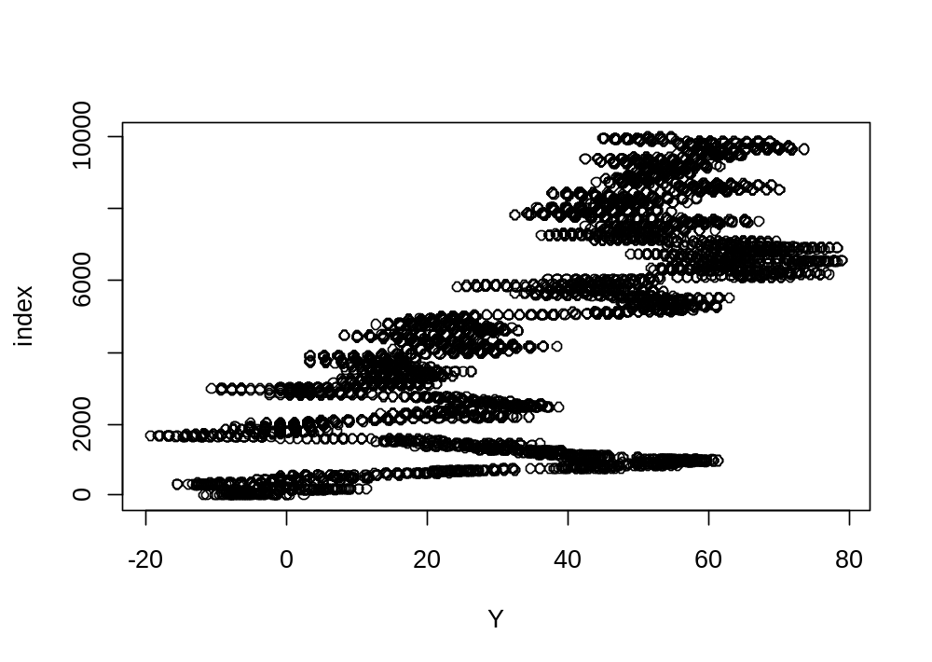
As we can see from the plot the error in our function gets large as the size of the array increases. The error increases linearly as the array size (subset) grow. The jerks in the relationship are due to random of numbers causing different error when a new number is added to the existing subset.
Our function is not a good way to calculate variance because for large numbers it accumulates errors. Hence for a large array we accumulate a great deal of error (100% sometimes). In order to rectify this we can use techniques like summing numbers in ascending order or pair wise (w. r. t. size).

